**Proposal: Improvements and maintenance costs for** [***Guide to Polkadot-JS***](https://anaelleltd.github.io/polkadotjs-guide/)***.***

**3. Maintenance**

# Operational costs of the search widget.

Paid during the previous maintenance period.

# Upgrade existing webpages.

Completed for this period:

1. New presentation with interactive cards

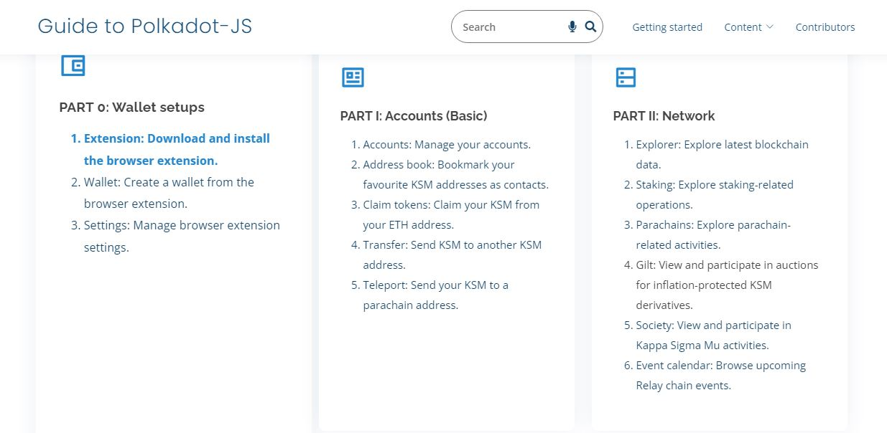

1. Improved referencing with anchor urls for each section

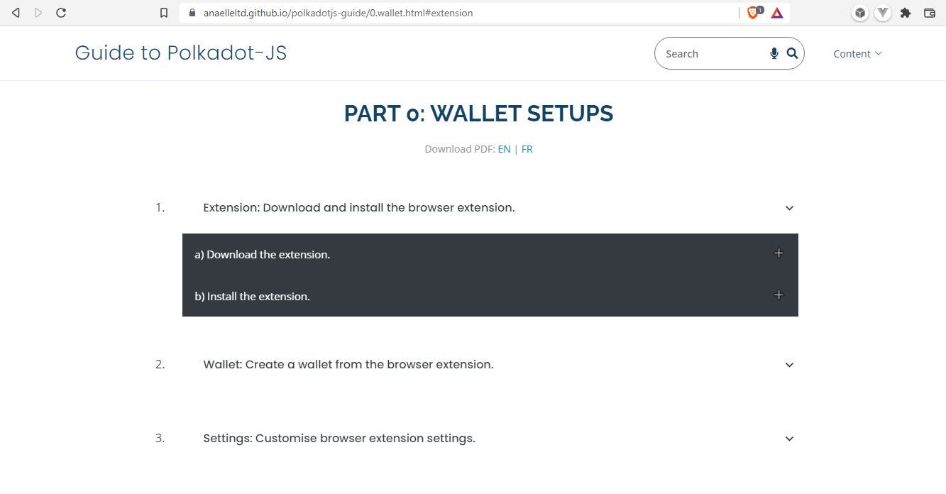

-Search analytics

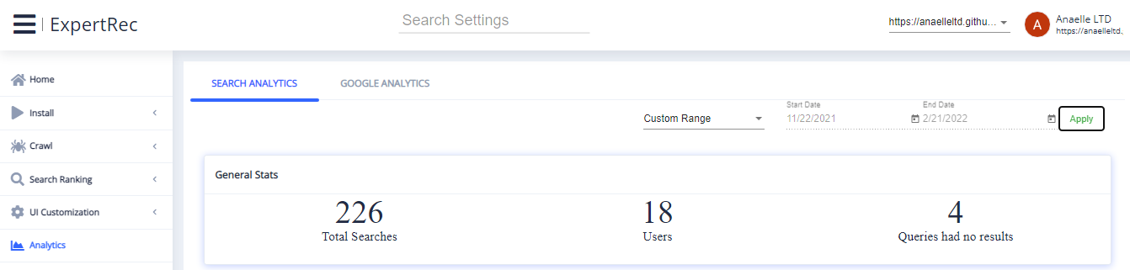

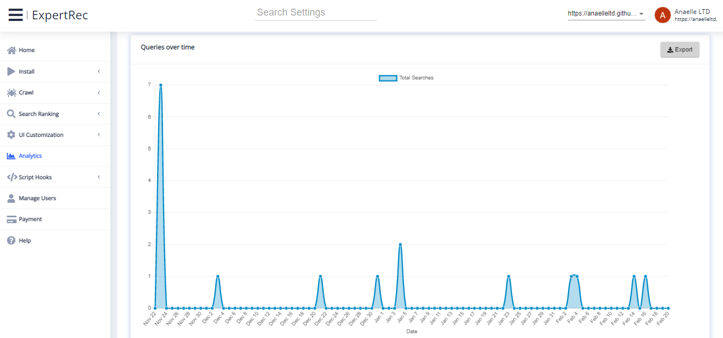

# Deliver *Part II* section 5 with in-depth explainers.

COMPLETED

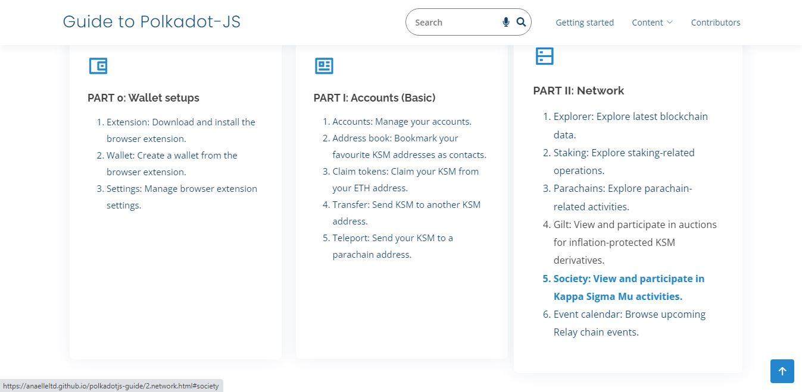

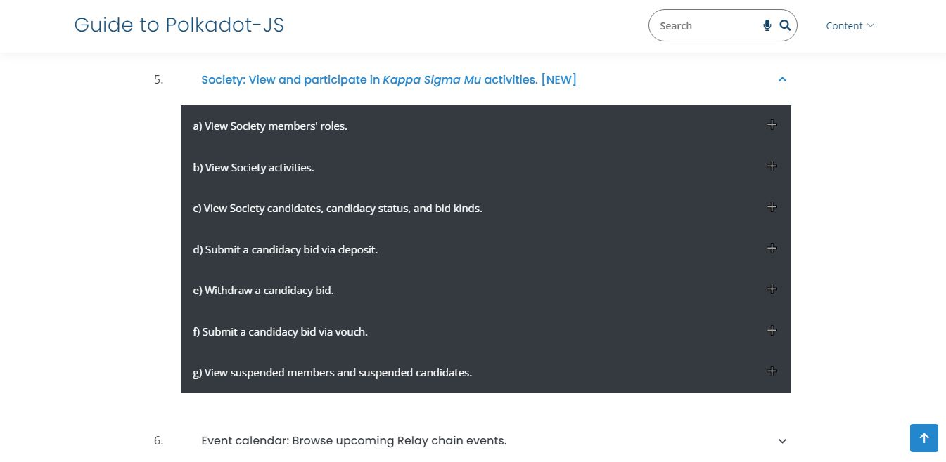

# Deliver ***Part VIII*** with in-depth explainers.

COMPLETED

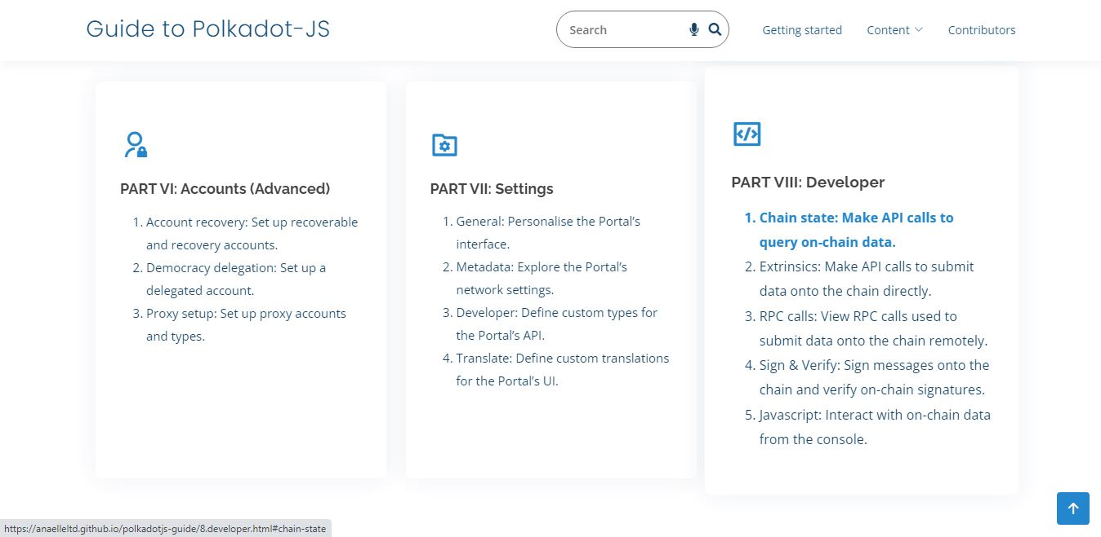

# Reference content on social channels.

Completed for this period:

1. Reddit:

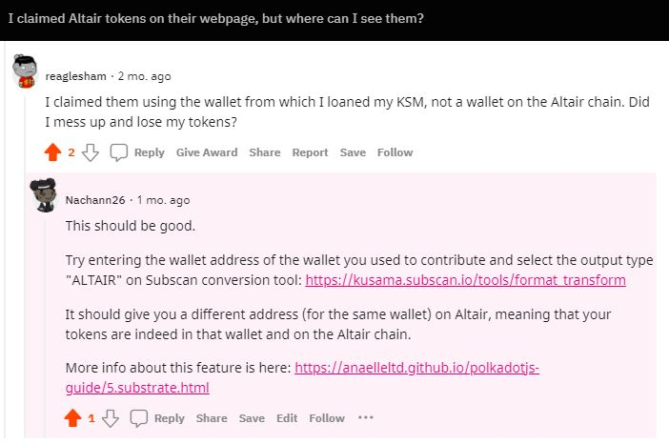

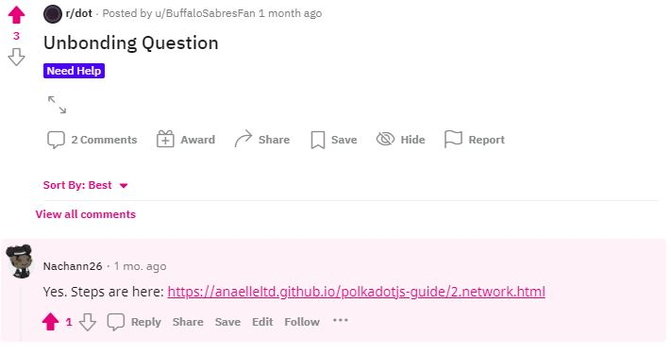

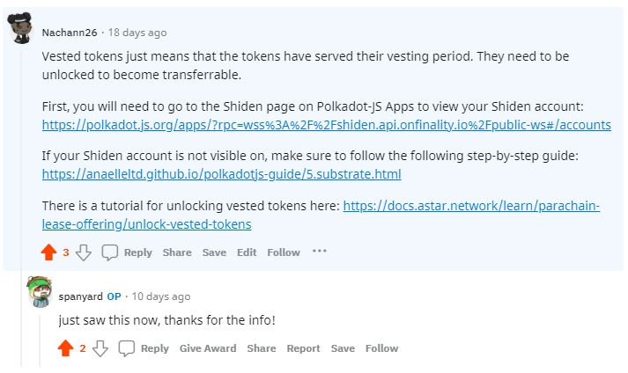

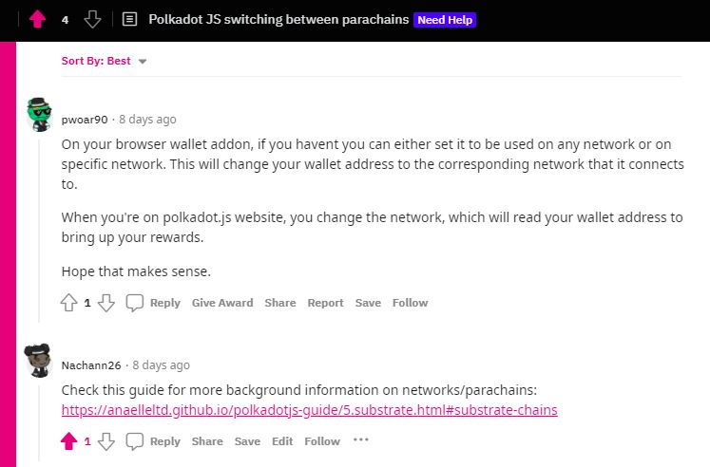

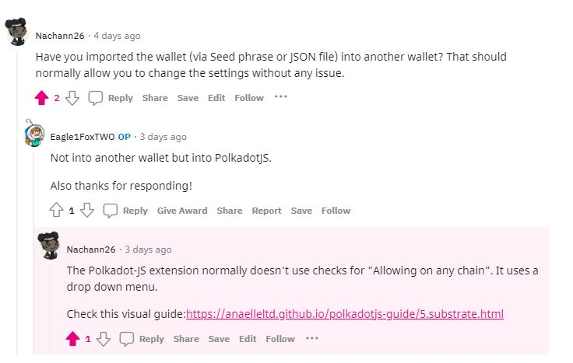

1. Twitter:

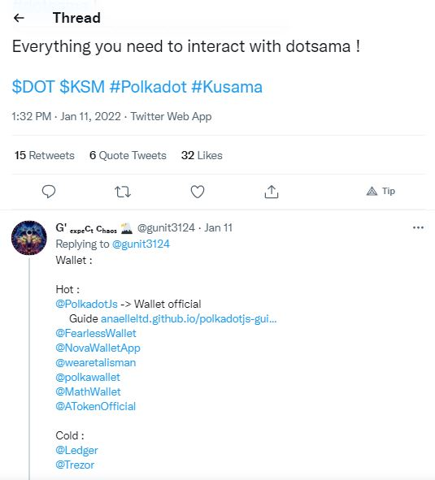

# Monitor traffic on individual pages with Google Analytics.

Completed for this period:

1. Number & origin of views:

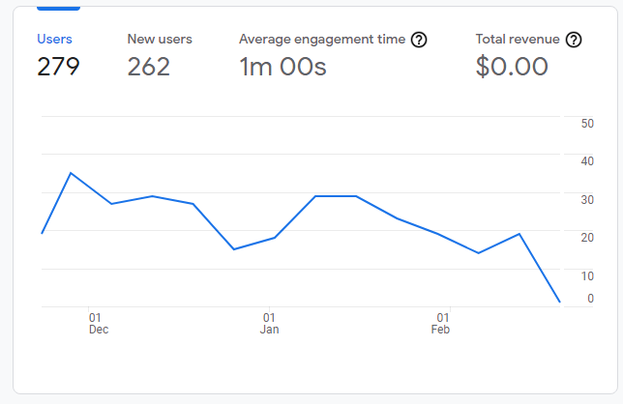

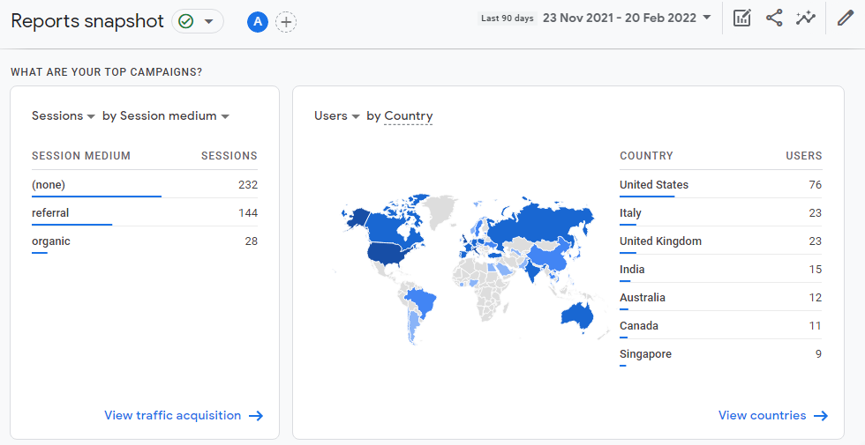

1. Number & origin of new users:

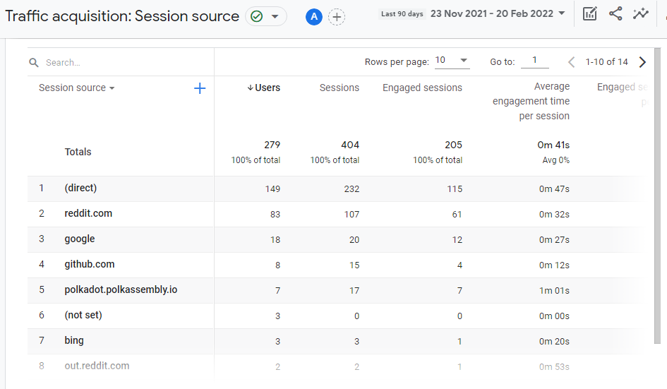

1. Most common user language(s):

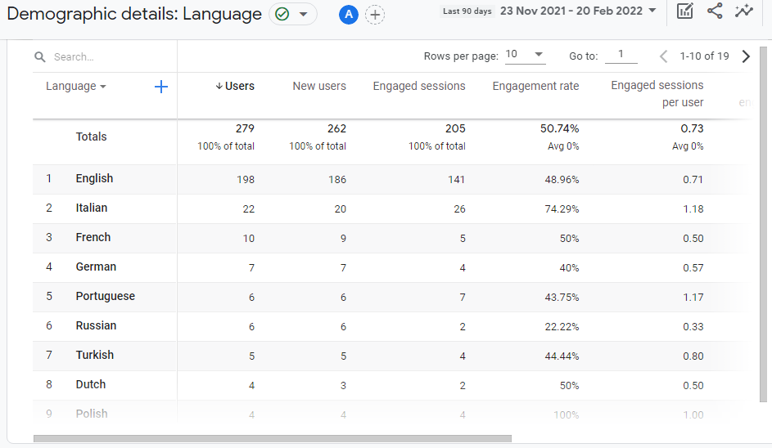

1. Most common user device(s):

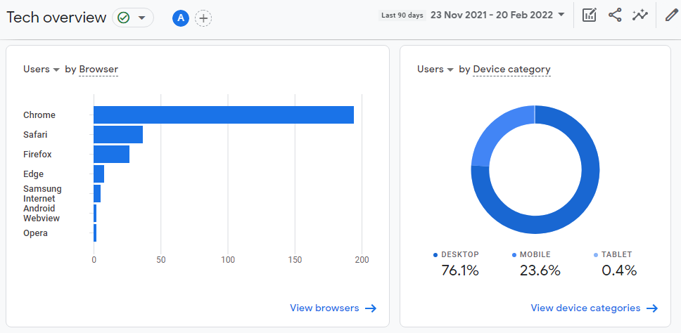

1. Most viewed content(s):

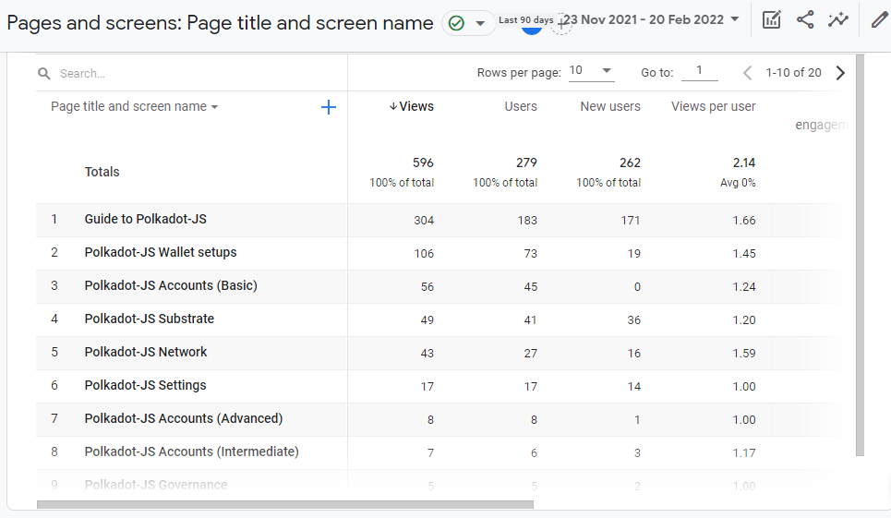

# Deliver new content in line with new/additional Polkadot-JS functionalities.

N/A for this period.